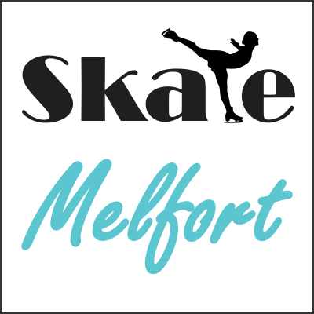
Clothing Order Form 2020

Name:______________________

 | Size | Quantity | Name on  Back of Jacket  (optional) | Total $
Jacket
$100.00
Pants
$85.00
Face Mask
$11.00
Grand Total $

Please submit orders by Nov 5, 2020 to: skatemelfort@gmail.com

Tax is included in listed prices. You will be notified when payment is due.

*If the jacket or arms are too long or short, they can be adjusted by 2 inches. Contact Skate Melfort if you would like this option.
*A lining could be added to the jacket for an additional $35.00, however, all jackets must be the same so everyone wanting to order would have to want this option.
.

